Task 1 – Demonstration of volume creation using snapshot of an external volume with Elastic Block Storage.

i. Creation of EC2 Instance (Amazon Linux AMI – us-east-1)

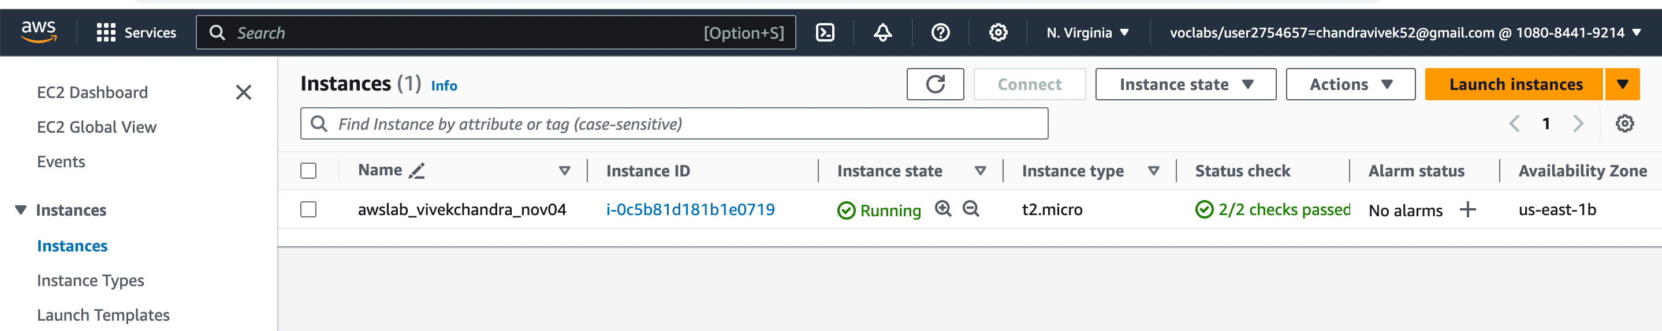

ii. SSH to the EC2 instance.

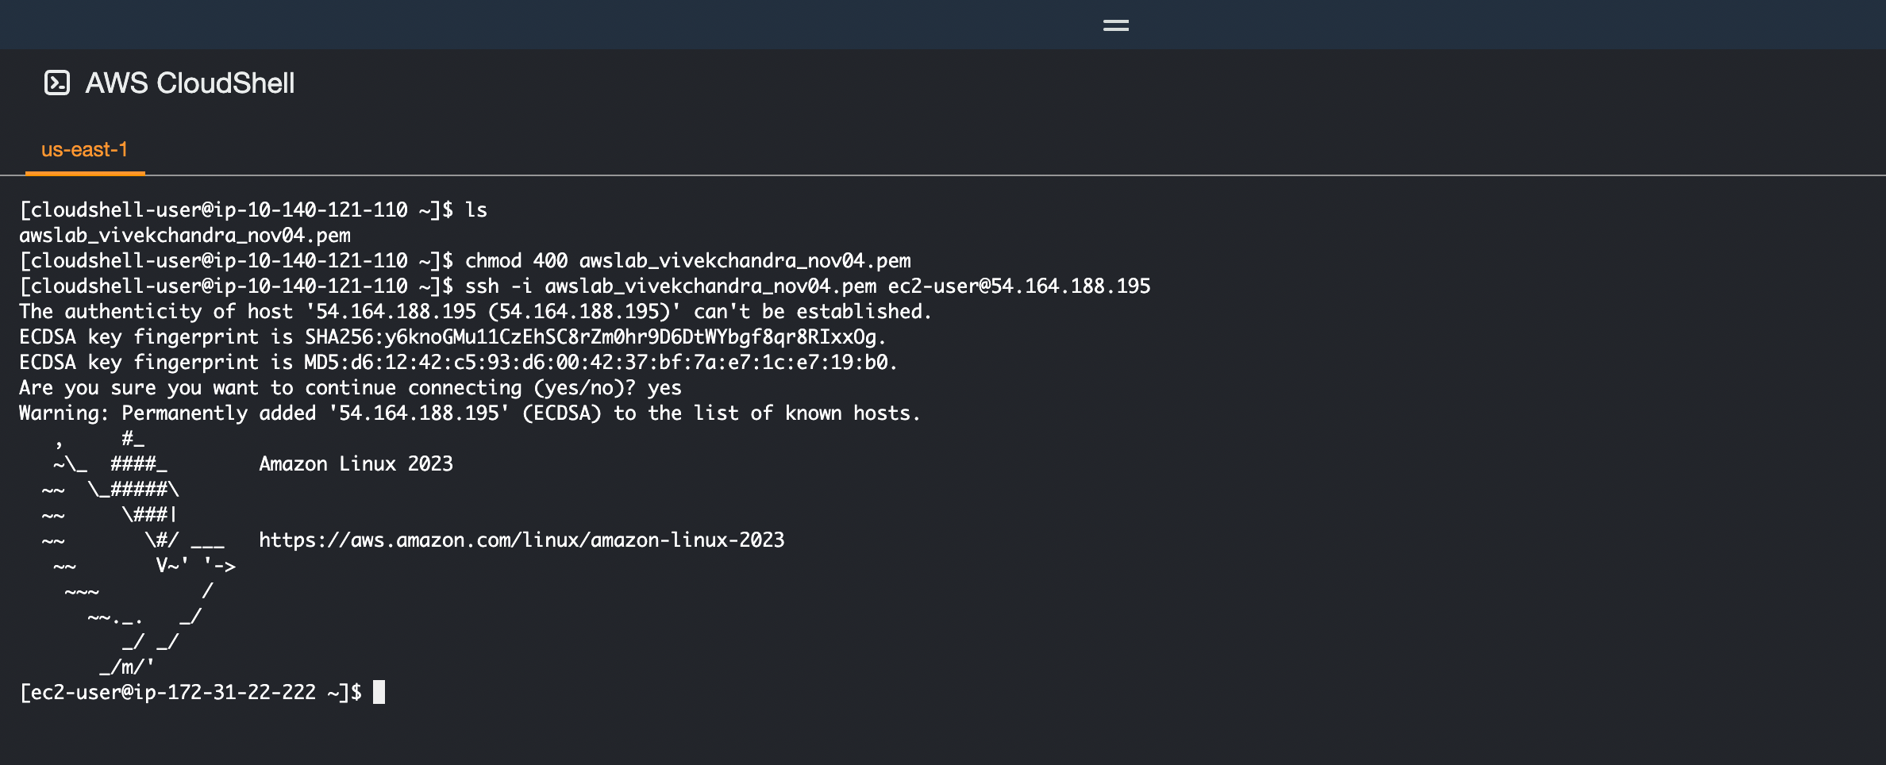

iii. Creation of External Magnetic Volume (1 GiB) and attachment to the EC2 instance.

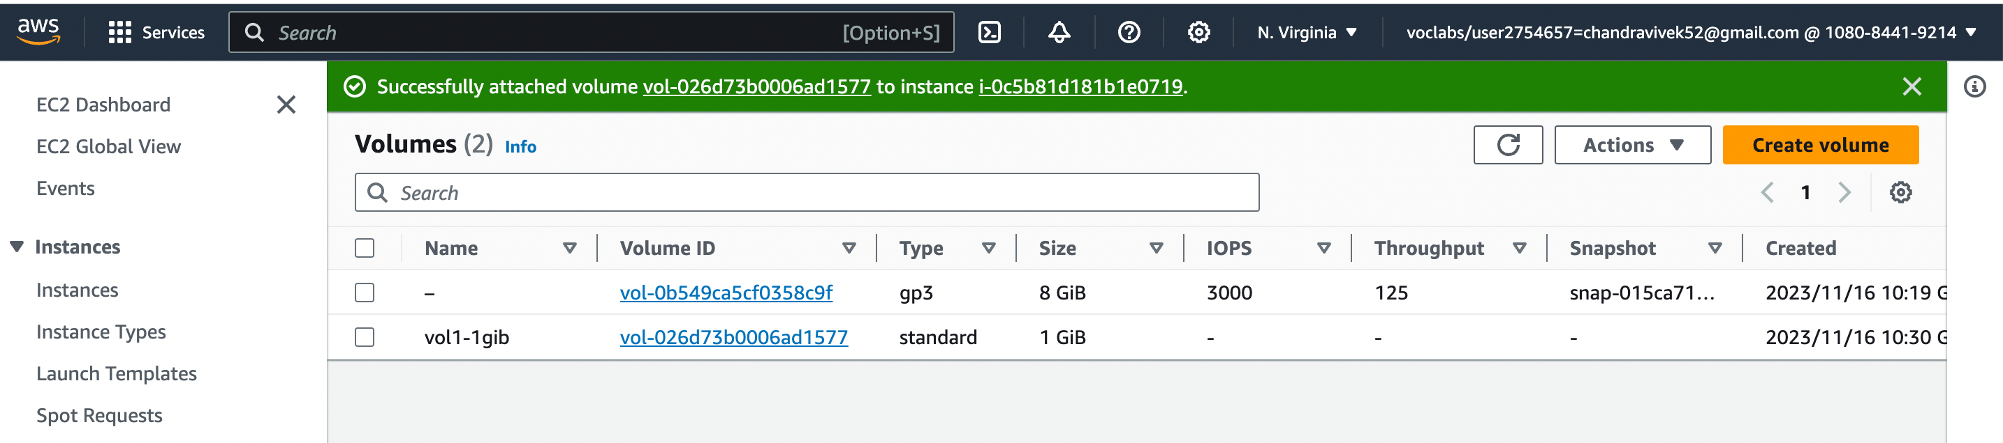

iv. Formatting the magnetic volume.

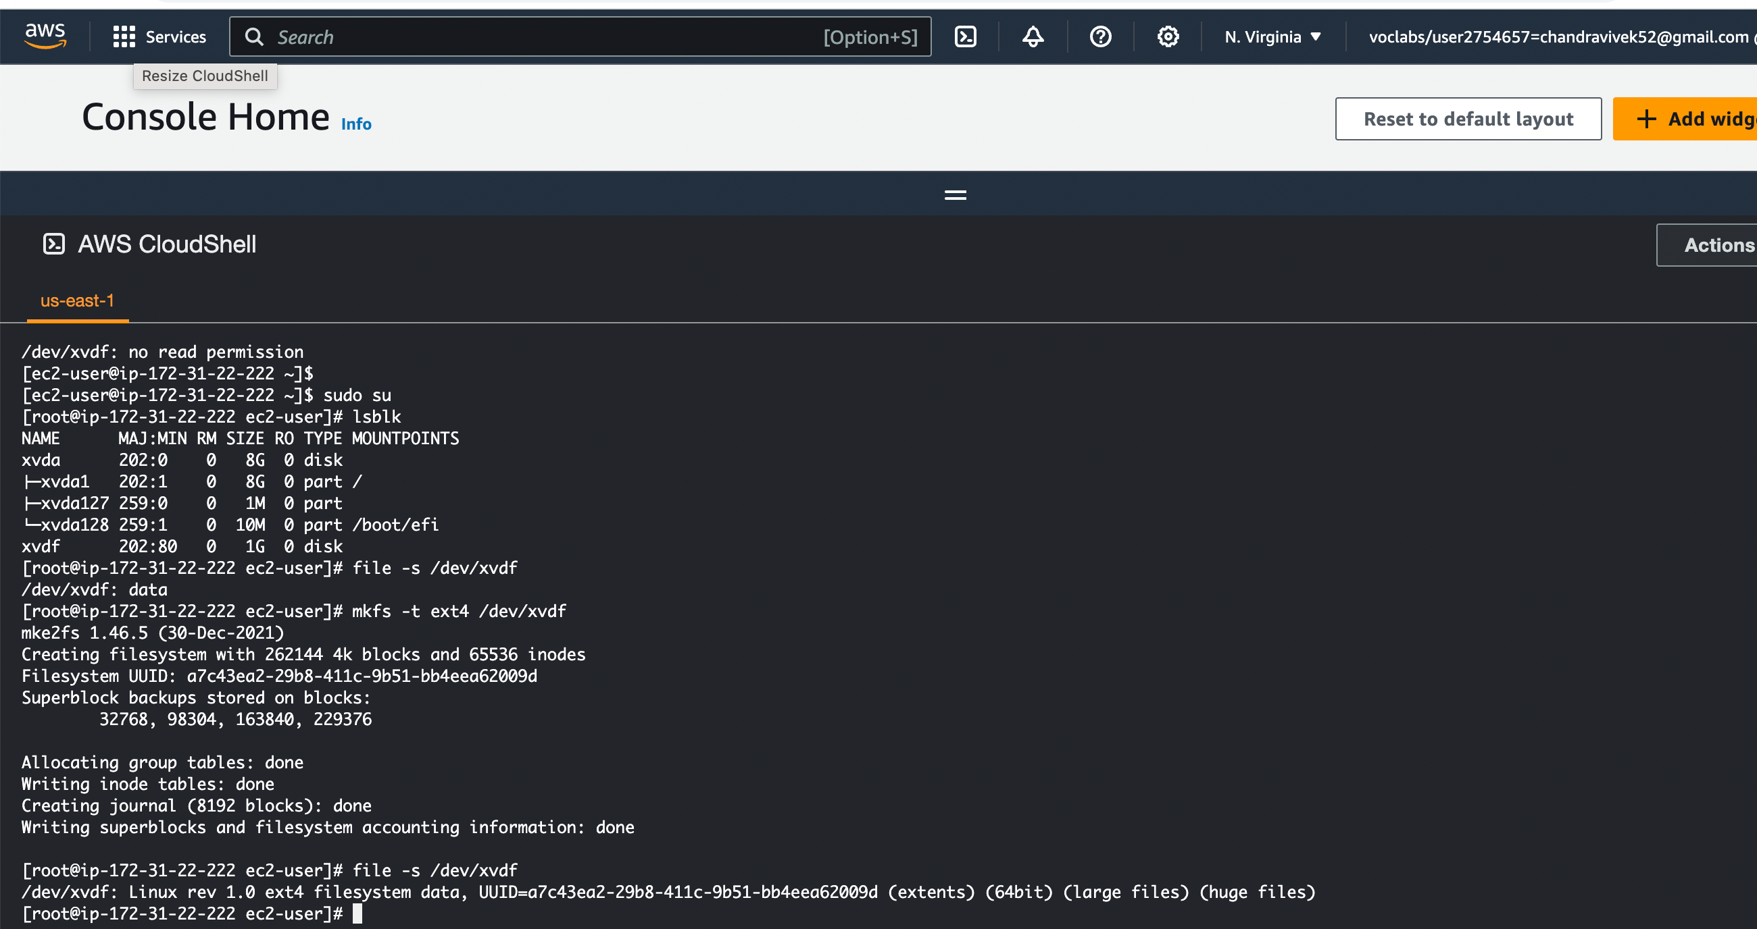

v. Mounting the volume, creation of a sample text file and unmounting the magnetic volume.

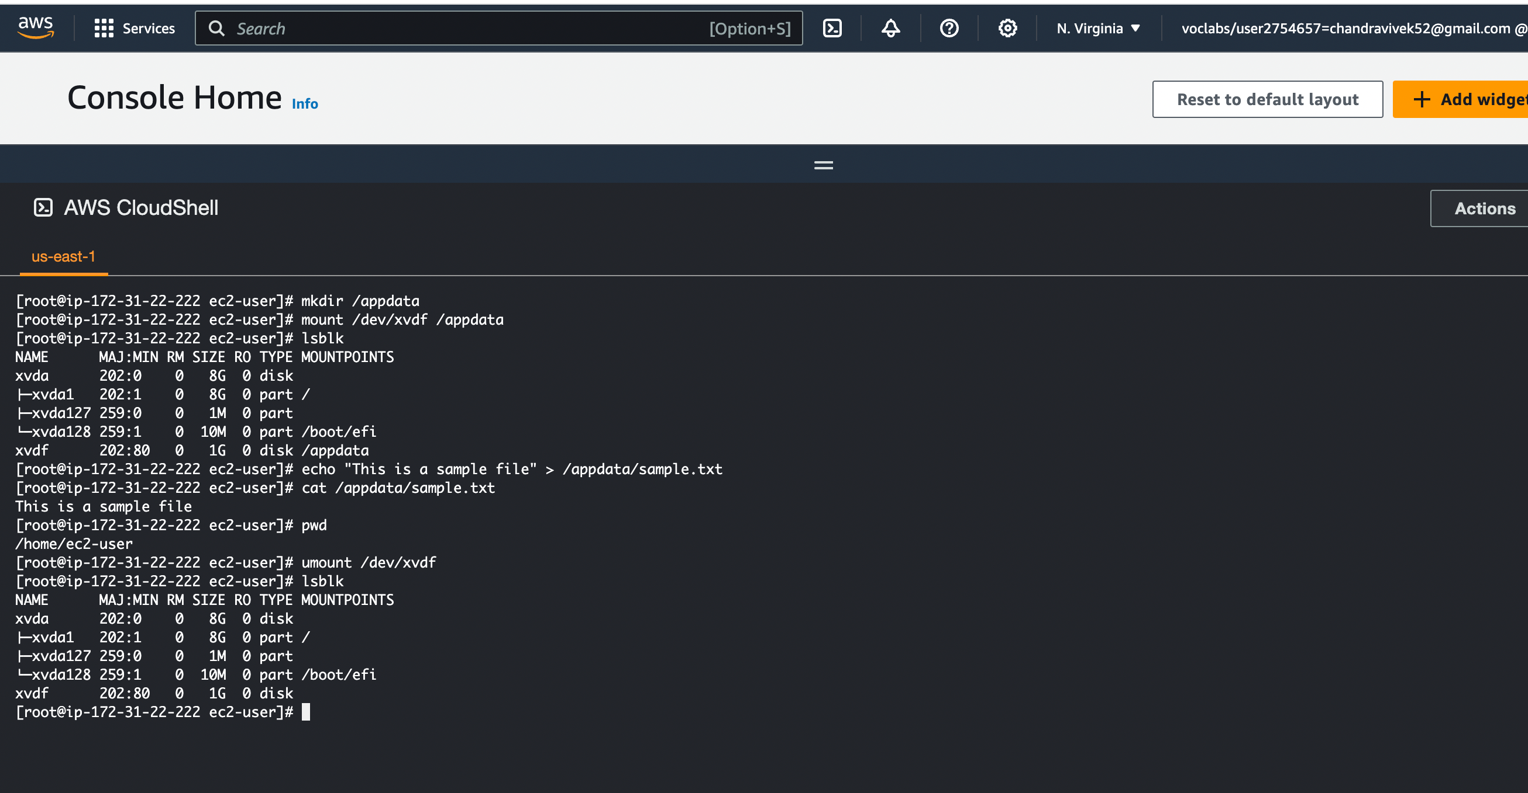

vi. Detaching the magnetic volume.

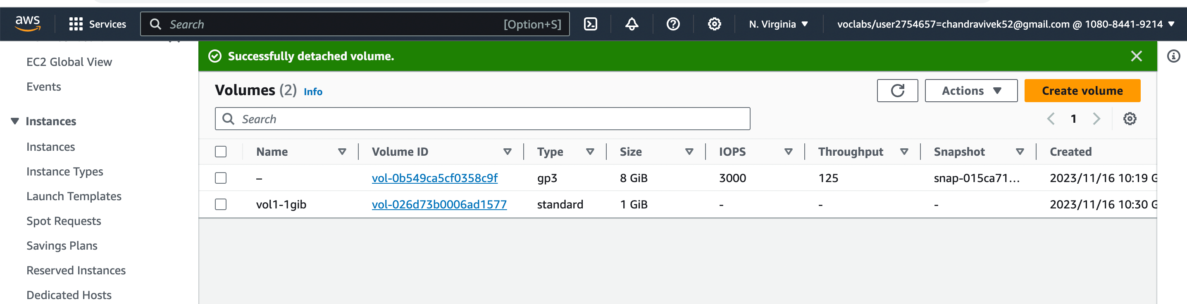

vii. Creation of snapshot from the magnetic volume (1 GiB).

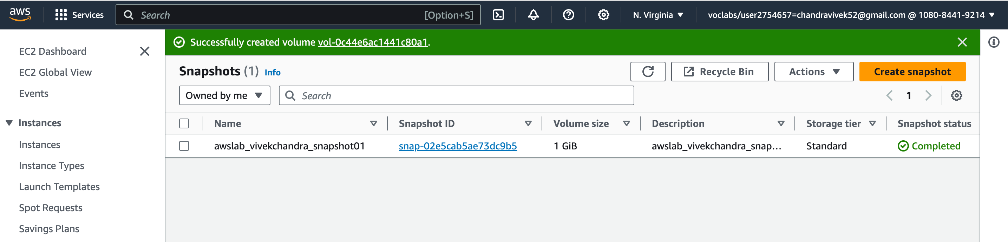

viii. Creation of ssd-gp2 external volume (2 GiB) from the snapshot.

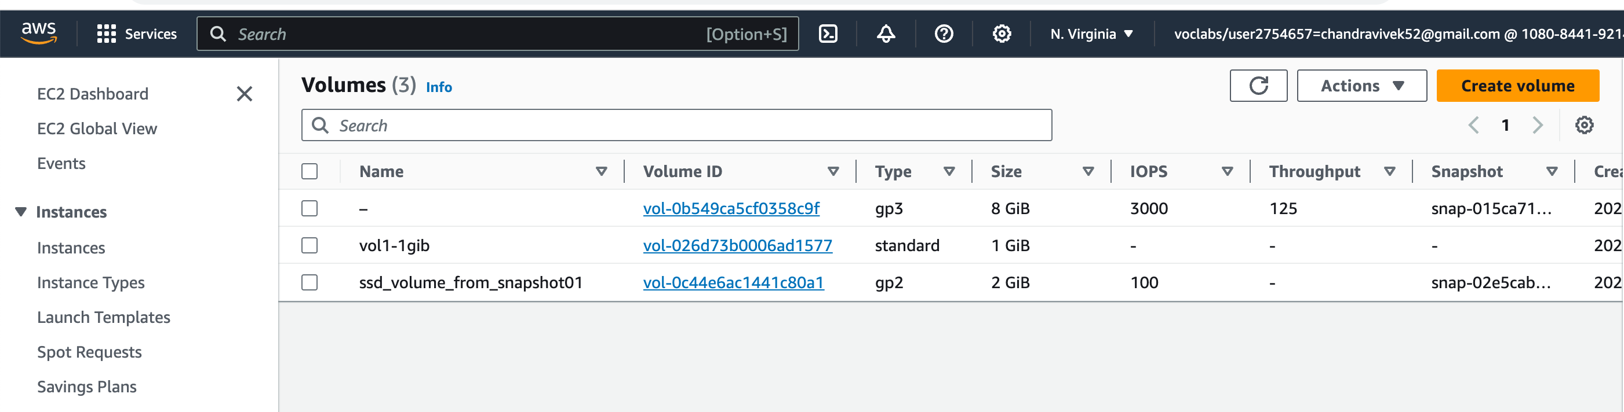

ix. Attaching the ssd-gp2 volume to the EC2 Instance.

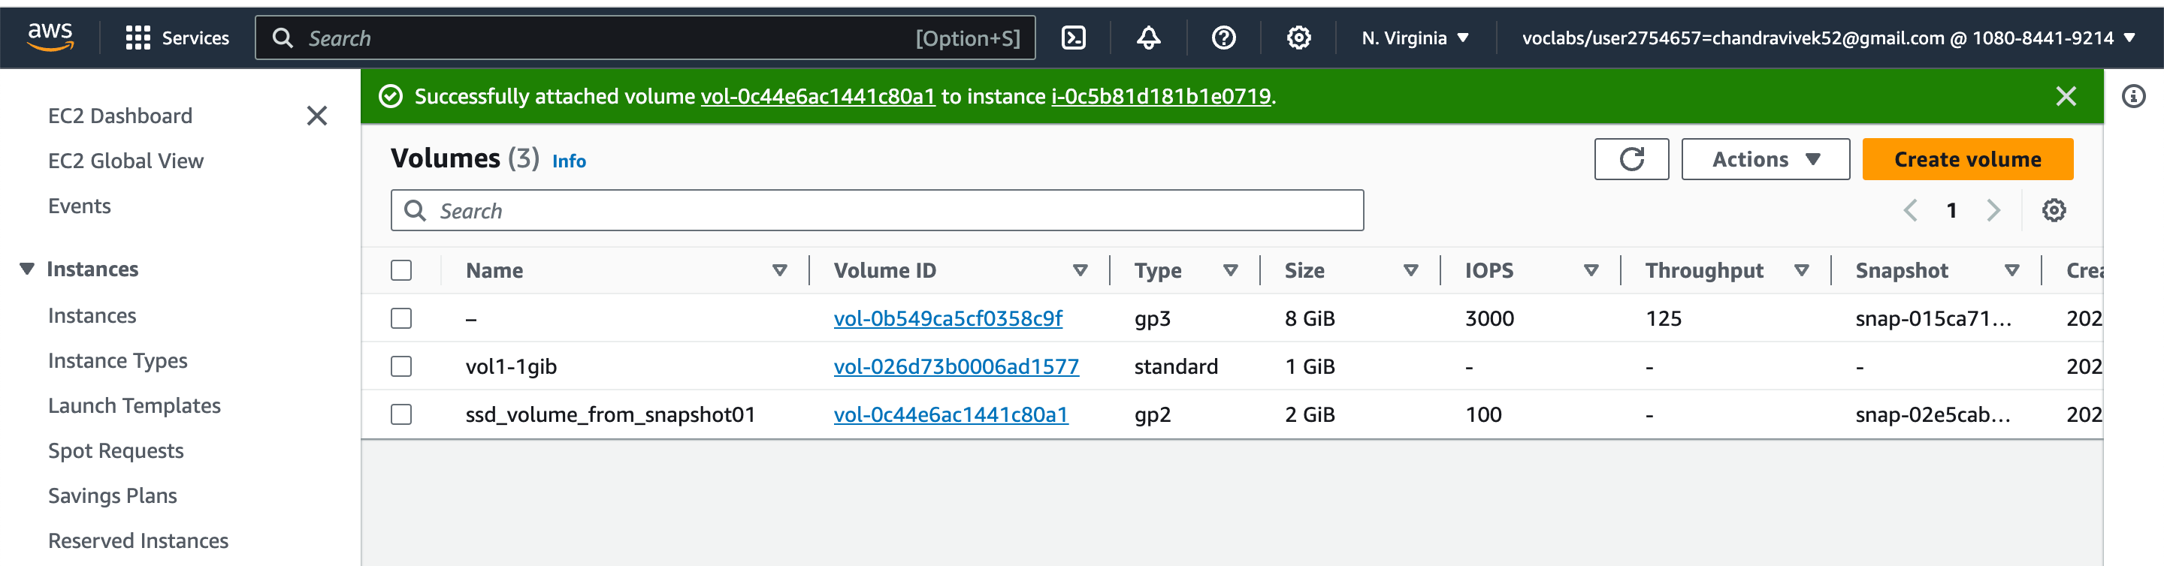

x. Mounting the ssd-gp2 volume and validating the existence of sample.txt file.

